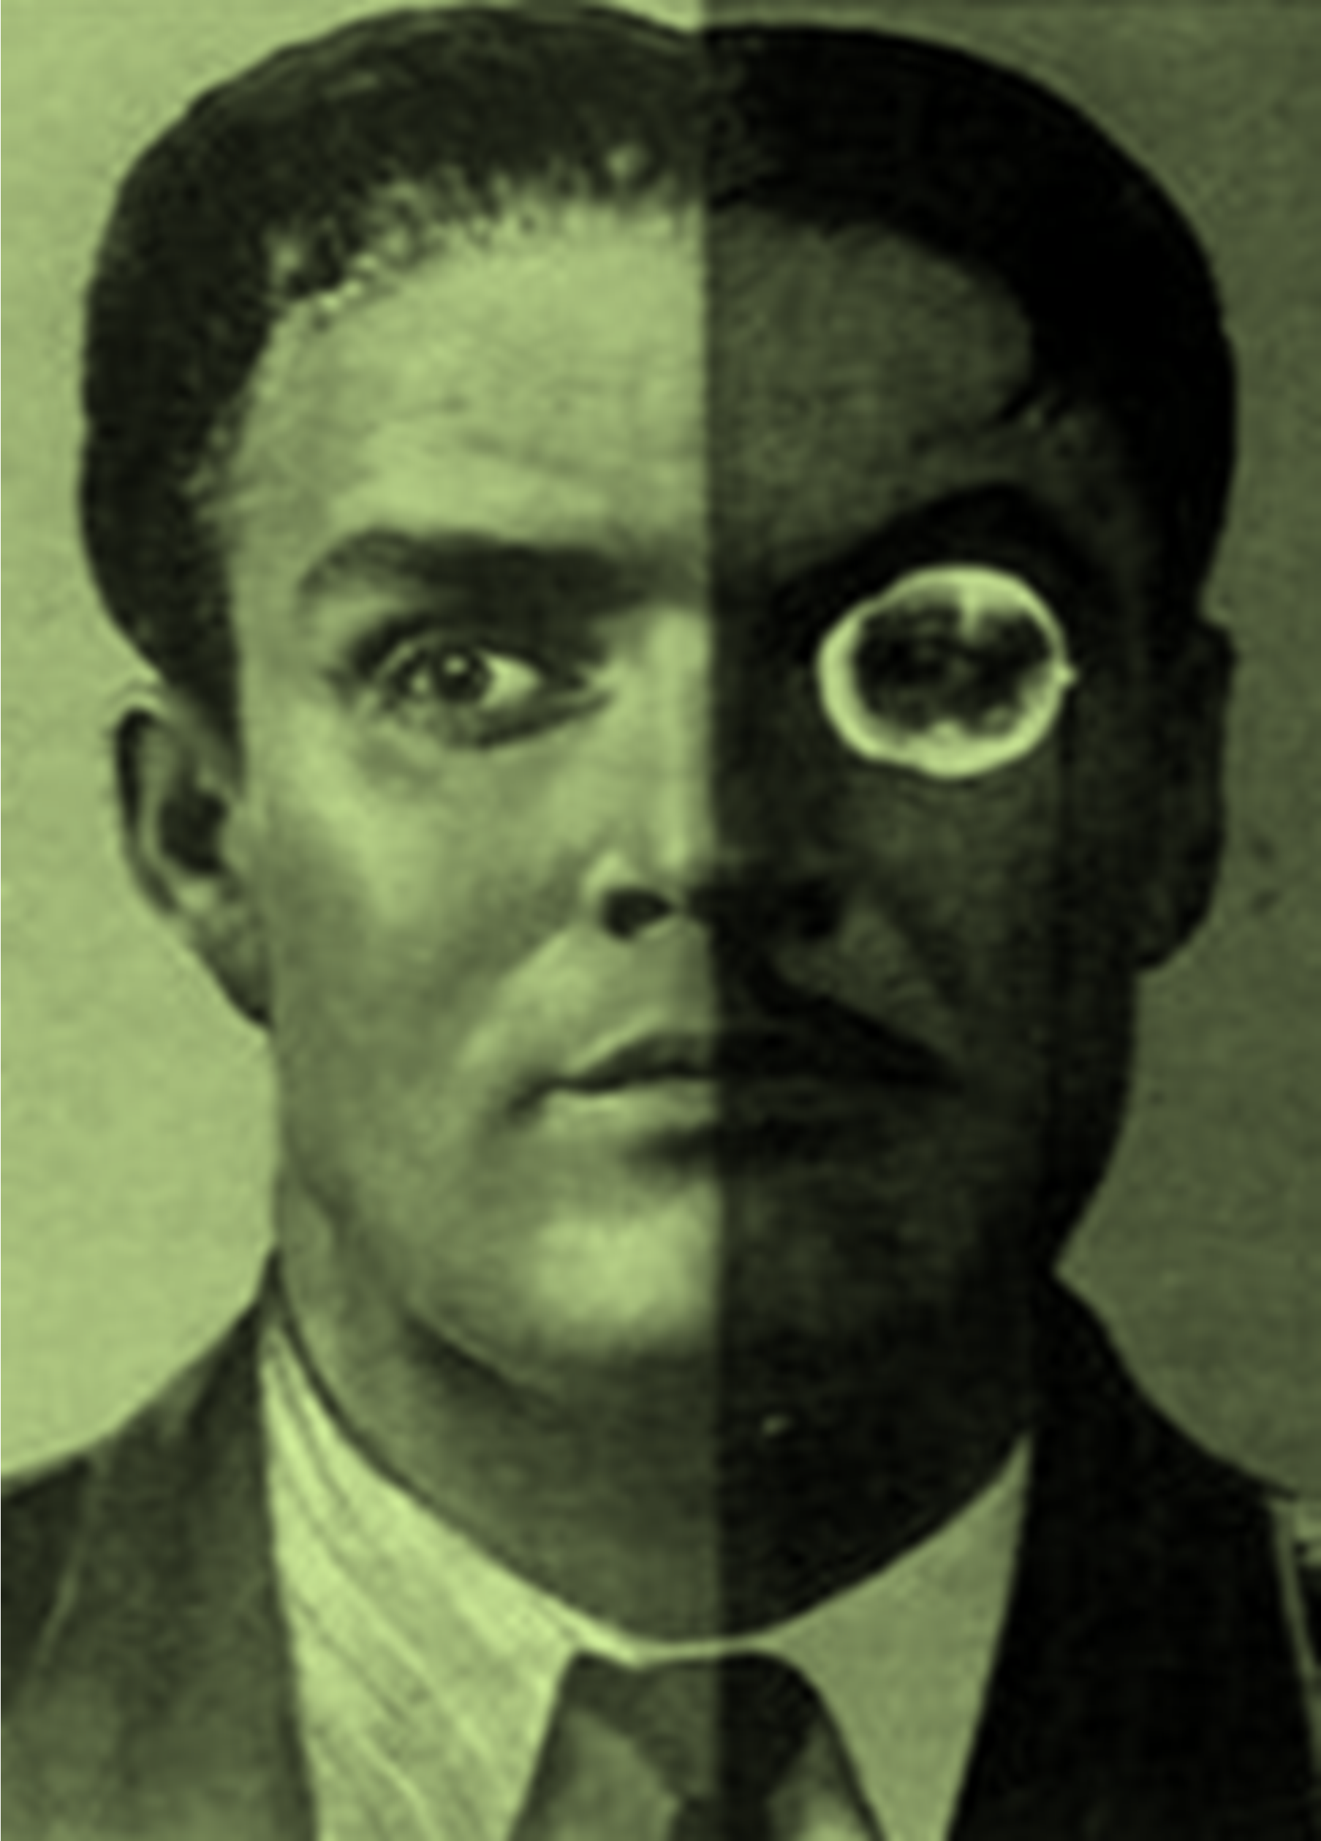
PRIVATE LIVES, PUBLIC PERSONAS: DIARIES, BIOGRAPHY AND PERSONAL NARRATIVE UNDER COMMUNISM

IRISH ASSOCIATION FOR RUSSIAN, CENTRAL AND EAST EUROPEAN STUDIES ANNUAL CONFERENCE
K114, SCHOOL OF HISTORY AND ARCHIVES, UCD, APRIL 23-24
FOR REGISTRATION DETAILS PLEASE CONTACT susan.grant@ucd.ie OR james.m.ryan@student.ucc.ie

