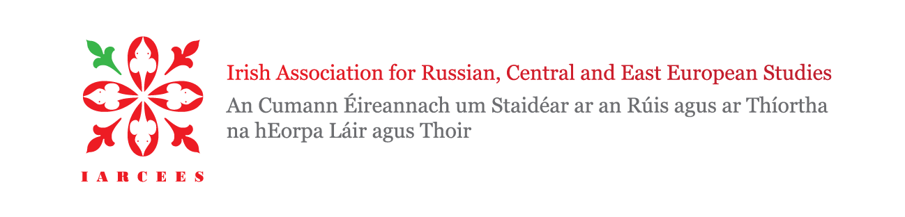

Membership Renewal Invoice

Please fill in this form and forward along with your payment to Treasurer IARCEES, c/o Róisín Healy, Department of History, NUI Galway, University Road, Galway, Ireland, H91 TK33.

Electronic payments may be made to:

Euro and international payments:
Bank name: Bank of Ireland, College Green Dublin 2
Account Name: Irish Association for Russian and East European Studies Current Account
Bank Identifier Code: BOFIIE2D
IBAN: IE09 BOFI 9000 1716 3328 94

If you wish to set up a standing order for annual membership renewal, please print off the standing order form from the membership section of the Association website at www.iarcees.org, and submit the completed form to your own bank.

Please ensure that all your payments are accompanied by your full name and membership category so that your subscription status can be updated. Should you have any queries, please send an e-mail to treasurer@iarcees.org.

Please note: Membership of the Association entitles you to a reduced conference registration fee.

Thanking you for your continued support.

The Treasurer, IARCEES

I would like to renew my membership as indicated below:
Subscription Period | May 2022-April 2023 | Subscription
 |  | Please tick as appropriate: | Amount Due:
 |  | One year | €20/ST£15
 |  | Post-graduate | €15/ST£10

Name: | Date:
E-mail address: | Institutional link:

We are currently compiling a database of Experts on Central and Eastern Europe and Russia in Ireland. Please tick here if you would like to have your details published on our website.

